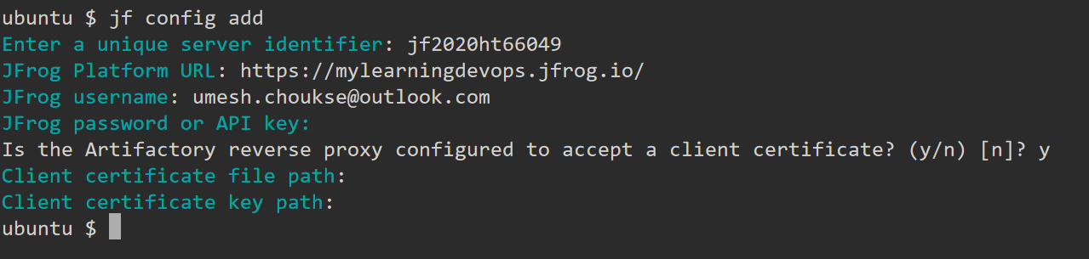

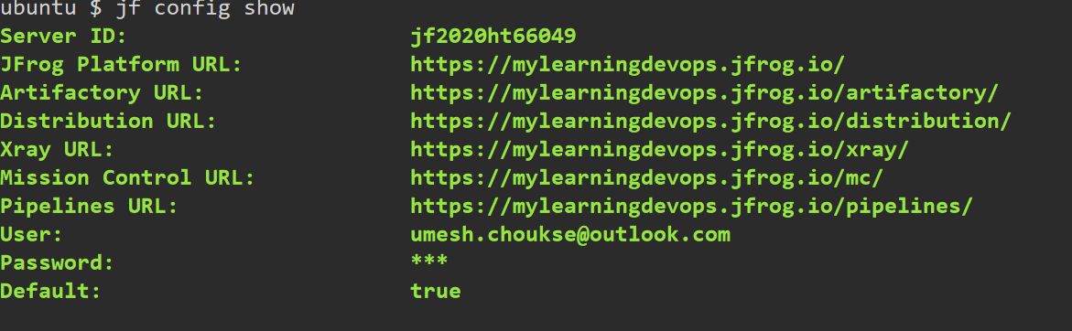

cmVmdGtuOjAxOjE3NTE4MjgyODE6eE9oNTVBZmViNWk4S2RuTG5UOTkwbHlRdFBT